**Why are there so many ENSO indexes, instead of just one?**

*Author:*

[Anthony Barnston](https://www.climate.gov/author/anthony-barnston)

*Thursday, January 29, 2015*

Some people have probably noticed that over the past year, this blog has mentioned several different ways to measure and monitor ENSO—whether we are in an El Niño, La Niña, or neither. At NOAA, the official ENSO indicator is the [Oceanic Niño Index (ONI)](http://www.cpc.ncep.noaa.gov/products/analysis_monitoring/ensostuff/ensoyears.shtml), which is based on sea surface temperature (SST) in the east-central tropical Pacific Ocean. But we have also mentioned other ways of measuring ENSO. Here, we will review some of them and then provide reasons why several different indicators are best for monitoring ENSO.

Historically, an **index** has been a common way to summarize the ENSO status. An index is a number scale in which all the individual factors needed to describe a complicated phenomenon are boiled down to a single number.  That single number then can be tracked over time.

**Air pressure indexes**

The oldest indicator of the ENSO state is the [Southern Oscillation](http://www.climate.gov/news-features/blogs/enso/en-so) Index (SOI): the difference between the atmospheric pressure at sea level at Tahiti and at Darwin (1); see Fig. 1. A seesaw in pressure at these locations reflects the atmospheric component of ENSO, discovered in the early 1900s by Walker and Bliss (1932) and others. During El Niño, the pressure becomes below average in Tahiti and above average in Darwin, and the Southern Oscillation Index is negative. During La Niña, the pressure behaves oppositely, and the index becomes positive.

[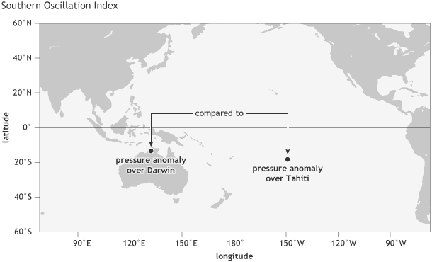](https://www.climate.gov/sites/default/files/Fig1_ENSOindices_SOI_large.png)

*Figure 1. Location of the two stations whose sea level pressures contribute to the Southern Oscillation Index (SOI): one over Tahiti, in French Polynesia, and one over Darwin, Australia. NOAA Climate.gov image by Fiona Martin.*

The fact that the SOI is based on the sea level pressure at just two individual stations means it can be affected by shorter-term, [day-to-day or week-to-week fluctuations](http://www.climate.gov/news-features/blogs/enso/what-mjo-and-why-do-we-care) unrelated to ENSO. But[averaging the index values over months or seasons](http://www.climate.gov/news-features/blogs/enso/how-will-we-know-when-el-ni%C3%B1o-has-arrived) helps to isolate more sustained deviations from the average, like those associated with ENSO.

Another limitation of the Southern Oscillation Index is that both Tahiti and Darwin are located somewhat south of the equator (Tahiti at 18˚S, Darwin at 12˚S), while the ENSO phenomenon is focused more closely along the equator. The [Equatorial Southern Oscillation I](http://www.cpc.ncep.noaa.gov/data/indices/)ndex overcomes this problem, as it uses the average sea level pressure over two large regions centered on the equator (5˚S to 5˚N) over Indonesia and the eastern equatorial Pacific (see Fig. 2).

[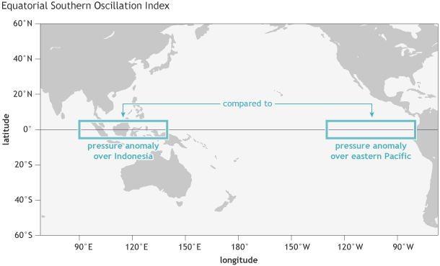](https://www.climate.gov/sites/default/files/Fig2_ENSOindices_ESOI_large.png)

*Figure 2. Location of the two rectangular regions whose average sea level pressures are used to compute the Equatorial Southern Oscillation Index: One over the eastern equatorial Pacific, and one over Indonesia. NOAA Climate.gov image by Fiona Martin.*

However, data for this index only extend back to 1949 (2). In contrast, the Tahiti-Darwin index goes back to the late 1800s because of longer station records. Due to its longer records, the Tahiti-Darwin index was used to represent the ENSO state in a set of landmark studies relating ENSO to its global climate effects (Ropelewski and Halpert 1986, 1987, among others).

**Sea surface temperature indexes**

Later on, sea surface temperature data were increasingly used because the ocean was recognized to be a key player in ENSO (Bjerknes 1969, Rasmussen and Carpenter 1982, Wyrtki 1985) (3). Initially, certain regions were defined for measurements—namely Niño1, Niño2 (combined into Niño1+2), Niño3 and Niño4—because of consistently available data coming from ships passing through those areas. Later, an area called Niño3.4 was identified as being the most ENSO-representative (Barnston et al. 1997). Located between (and overlapping with) Niño3 and Niño4, this is the region whose temperature anomaly is reflected in the ONI (see Fig. 3).

[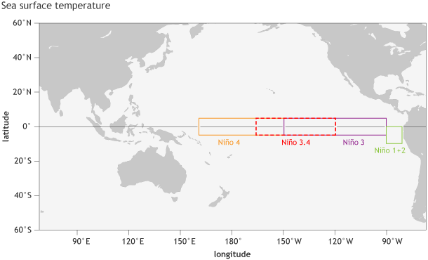](https://www.climate.gov/sites/default/files/Fig3_ENSOindices_SST_large.png)

*Location of the Niño regions for measuring sea surface temperature in the eastern and central tropical Pacific Ocean. The sea surface temperature in the Niño3.4 region, spanning from 120˚W to 170˚W longitude, when averaged over a 3-month period, forms NOAA’s official*[*Oceanic Niño Index*](https://www.climate.gov/news-features/understanding-climate/climate-variability-oceanic-ni%C3%B1o-index)*(the ONI). NOAA Climate.gov image by Fiona Martin.*

**Outgoing longwave radiation indexes**

With the introduction of continuous satellite-based data in 1979, another highly ENSO-relevant index became available—outgoing longwave radiation, which indicates the extent of convection (thunderstorm activity) across the tropical Pacific (4). By mapping outgoing radiation from cloud tops, we detect which areas in the tropical Pacific are rainier (or drier) than average. Above-average thunderstorm activity often (not always) occurs in areas having above-average sea surface temperature. The outgoing longwave radiation is therefore not only very relevant to the ENSO state, but also serves as a key linkage to the remote climate [teleconnections](http://www.climate.gov/news-features/blogs/enso/how-enso-leads-cascade-global-impacts) outside the tropical Pacific region (e.g., . Chiodi and Harrison 2013).

**Wind indexes**

In addition to sea level pressure, sea surface temperature, and outgoing longwave radiation, there are also [wind-based indexes](http://www.cpc.ncep.noaa.gov/data/indices/) across the tropical Pacific, which measure the movement of air flow in the upper and lower branches of the Pacific [Walker circulation](http://www.climate.gov/news-features/blogs/enso/walker-circulation-ensos-atmospheric-buddy) (5).

**Which one’s the best?**

So, now you might ask why we continue to use so many different measures of ENSO. Why don’t we settle on just one index? Well, ENSO is [multifaceted](http://www.climate.gov/news-features/blogs/enso/what-el-ni%C3%B1o%E2%80%93southern-oscillation-enso-nutshell), involving different aspects of the ocean and the atmosphere over the tropical Pacific. By analogy, consider the process of hiring someone into your organization. You want someone who is proficient and experienced in your specialty. But you also want a good team player, a good writer and speaker, and someone who interacts comfortably with the public. So just a score on a written test would not be sufficient; you and your coworkers would want to interview the person to understand their other qualities (6). Diagnosing the ENSO state works in a similar fashion. Figure 4 shows the locations of the regions used for the two Southern Oscillation indexes shown in Figs. 1 and 2, and for the current official sea surface temperature index (Niño 3.4).

Also, we cannot measure one aspect of the entire tropical Pacific perfectly, so we get a better picture when we consider a few related measures (7). Another reason for multiple indexes is that we want to to compare different ENSO events in history, but not all ocean and atmospheric indexes go far back in time.

[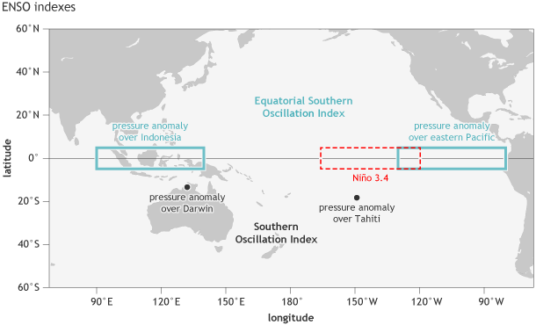](https://www.climate.gov/sites/default/files/Fig4a_ENSOindices_Nino3.4only_large.png)

*Location of the stations used for the Southern Oscillation Index (Tahiti and Darwin, black dots), the Equatorial Southern Oscillation Index (eastern equatorial Pacific and Indonesia regions, outlined in blue), and the Niño3.4 region in the east-central tropical Pacific Ocean for sea surface temperature (red dashed line). NOAA Climate.gov image by Fiona Martin.*

To deal with the multiple aspects of ENSO, you might imagine that more than one index could be combined into a composite index, such as one based on both sea surface temperature and pressure anomalies, or other combinations. Such composite indexes have been explored. Although these indexes are interesting and innovative, so far they have not been widely used by any of the global forecast producing centers. Why? Well, similar to when we want to justify hiring a potential employee, we often want to list the various skill sets of the person separately rather than to combine them into a single “candidate quality” score using a complex automated formula. This way we can explain just what went into our hiring decision, and also know where future improvements may be needed.

A final reason for maintaining separate individual indexes is that the location of the user can matter. Different national meteorological and climate agencies may emphasize certain indexes because they reflect the aspects of ENSO that impact their county most strongly. For example, people on a tropical Pacific island might care more about SST, while in a country farther away from the tropical Pacific, they might care more about large-scale changes in sea level air pressure.

So—because ENSO is such a large, complex, and dynamic system, using several different indexes will always be informative and beneficial in measuring the ENSO state. This multifaceted perspective was clearly used in assessing the ENSO status and outlook during 2014.

**Footnotes**

(1) The sea level pressure (SLP) readings at Tahiti and Darwin are each **standardized,** so that they fall between -1 and +1 about two-thirds of the time, and rarely go outside of -2.5 to 2.5. Standardization is done to adjust for seasonal differences in both the average and in the year-to-year range of variability at each of the two stations, so that each station always contributes equally to the index.

The difference between these two standardized SLPs is then itself standardized, so that it falls between -1 and +1 about two-thirds of the time. **How is standardization done, exactly?** Okay, here goes: Standardization re-scales a set of numbers in two steps. In the first step, the average of the numbers is computed, and that average is then subtracted from each number. This causes any number below the average to become a negative number, and ones above average to become positive. The average of all the new numbers then becomes zero.

Then, in the second step, the numbers are further re-scaled so that their range typically ends up only between about -2.5 and 2.5. So, if their original range is much larger than this, then the numbers are compressed; if originally smaller, they are stretched. This second step of re-scaling is done by first computing the **standard deviation** of the numbers, which is a measure of the extent to which the numbers vary from one another. The formula for the standard deviation is not given here, but can easily be looked up, and basically calculates by how much the numbers are scattered around their average. To give an idea of how large the standard deviation is, the standard deviation of the weight of men in the United States is roughly 30 pounds. If the men’s weights are distributed in a normal and symmetric pattern, this means that about two-thirds of the men are between 30 pounds below the average and 30 pounds above it—that is, about one standard deviation’s worth on either side of the average.

The numbers coming out of the first step above (subtracting the average, which incidentally is about 165 pounds for men’s weight) are divided by this standard deviation, and this is what causes the numbers to end up varying only between about -2.5 and 2.5. Since the Southern Oscillation Index (SOI) is usually standardized, it also varies between about -2.5 and 2.5, and is between -1 and 1 about two-thirds of the time. These are only rough guidelines, of course. In particular, the distribution of numbers may not necessarily be symmetric regarding the cases below and above average. In fact, the SOI shows some lack of symmetry, in that the most extreme negative cases are more negative than the most extreme positive cases are positive. This is because the strongest El Niño events are stronger than the strongest La Niña events, due to the physics of the ocean-atmosphere system.

(2) The Equatorial SOI is dependent on a complete gridded dataset, since much of the area is over ocean, and so the length of the record only extends back to the beginning of the reanalysis record. At NOAA CPC, the NCEP/NCAR Reanalysis goes back to 1949.

(3) Another desirable feature of sea surface temperatures (SSTs) is that they change more slowly than SLP, making it easier to identify ENSO, even when averaging over a period as short as a month or less.

(4) The thunderstorm activity is measurable through detection of the temperature of the cloud tops, which is lower for the higher-up (colder) cloud tops of stronger thunderstorms. So, low outgoing longwave radiation indicates high thunderstorm activity.

(5) Changes in winds can also help us to measure the onset of “westerly wind bursts,” which can influence the movement of warm water across the tropical Pacific, and can sometimes play a role in the initiation of an El Niño event.

(6) For another analogy, consider the diagnosis of clinical depression. It involves more than a person feeling unhappy too much of the time. It also involves a loss of interest in normal hobbies, decrease in physical energy, difficulty in concentrating on tasks, changes in sleep habits and/or appetite, and negative feelings about oneself. All of these indicators must last for at least a few weeks. Here, as is the case with ENSO, several different aspects need to be assessed.

(7) Although we rely on ships, buoys, and satellites to give us ENSO-related SST data, there are different assumptions made (using models and statistical methods) that provide estimates in regions we do not directly measure. So, if you look at SST datasets closely, different methods will give you slightly different estimates (Huang et al. 2013, 2015).

**References**

Bjerknes, J. (1969). [Atmospheric teleconnections from the equatorial Pacific.](http://docs.lib.noaa.gov/rescue/mwr/097/mwr-097-03-0163.pdf) *J. Phys. Oceanog.,***97**, 163-172.

Barnston, A. G., M. Chelliah, and S. B. Goldenberg, 1997: Documentation of a highly ENSO-related SST region in the equatorial Pacific. *Atmos.-Ocean*, **35**, 367-383.

Chiodi, A. M., and D. E. Harrison, 2013: El Niño impacts on seasonal U.S. atmospheric circulation, temperature, and precipitation anomalies: The OLR-Event perspective. *J. Climate*, **26**, 822–837.

Huang, B., M. L. L’Heureux, J. Lawrimore, C.-L. Liu, H.-M. Zhang, V. Banzon, Z.-Z. Hu, and A. Kumar, 2013: Why did large differences arise in the sea surface temperature datasets across the tropical Pacific during 2012?. *J. Atmos. Oceanic Technol.*, **30**, 2944–2953.

Huang, B. W. Wang, C. Liu, V. Banzon , H.-M. Zhang,, and J. Lawrimore, 2015: Bias adjustment of AVHRR SST and its impacts on two SST analyses. *J. Atmos. Oceanic Technol.*

Rasmussen, E. M. and T. H. Carpenter 1982: Variations in tropical sea surface temperature and surface wind fields associated with the Southern Oscillation/El Niño. *Mon. Wea. Rev*., **110**, 354-384.

Ropelewski, C. F., and M. S. Halpert, 1986: North American precipitation and temperature patterns associated with the El Niño Southern Oscillation (ENSO). *Mon. Wea. Rev*., **114**, 2352-2362.

Ropelewski, C. F., and M. S. Halpert, 1987: Global and regional scale precipitation patterns associated with the El Niño/Southern Oscillation. *Mon. Wea. Rev*., **115**, 1606-1626.

Walker, G.T. and Bliss, E.W., 1932. World Weather V, *Memoirs of the Royal Meteorological Society,***4,** 53-84.

Wyrtki, K., 1985: Water displacements in the Pacific and the genesis of El Niño cycles. *J. Geophys. Res., 90, 7129-7132.*

|  |  |  |  |  |
| --- | --- | --- | --- | --- |
| [[TAO](http://www.pmel.noaa.gov/tao/index.shtml)](http://www.pmel.noaa.gov/tao/index.shtml) | http://www.pmel.noaa.gov/tao/images/spc.gif | Definitions *of El Nino, La Nina, and ENSO* |  |  |
| http://www.pmel.noaa.gov/tao/images/spc.gif | | | |  |
| http://www.pmel.noaa.gov/tao/images/end_bubble.gif | | | | http://www.pmel.noaa.gov/tao/images/end_bubble_r.gif |

|  |
| --- |
| **Definitions of El Nino, La Nina, and ENSO**  El Niño (EN) is characterized by a large scale weakening of the trade winds and warming of the surface layers in the eastern and central equatorial Pacific Ocean. El Niño events occur irregularly at intervals of 2-7 years, although the average is about once every 3-4 years. They typically last 12-18 months, and are accompanied by swings in the Southern Oscillation (SO), an interannual see-saw in tropical sea level pressure between the eastern and western hemispheres. During El Niño, unusually high atmospheric sea level pressures develop in the western tropical Pacific and Indian Ocean regions, and unusually low sea level pressures develop in the southeastern tropical Pacific. SO tendencies for unusually low pressures west of the date line and high pressures east of the date line have also been linked to periods of anomalously cold equatorial Pacific sea surface temperatures (SSTs) sometimes referred to as La Niña.  The Southern Oscillation Index (SOI), defined as the normalized difference in surface pressure between Tahiti, French Polynesia and Darwin, Australia is a measure of the strength of the trade winds, which have a component of flow from regions of high to low pressure. High SOI (large pressure difference) is associated with stronger than normal trade winds and La Niña conditions, and low SOI (smaller pressure difference) is associated with weaker than normal trade winds and El Niño conditions. The terms ENSO and ENSO cycle are used to describe the full range of variability observed in the Southern Oscillation Index, including both El Niño and La Niña events.  There has been a confusing range of uses for the terms El Niño, La Niña and ENSO by both the scientific community and the general public. Originally, the term El Niño (in reference to the Christ child) denoted a warm southward flowing ocean current that occured every year around Christmas time off the west coast of Peru and Ecuador. The term was later restricted to unusually strong warmings that disrupted local fish and bird populations every few years. However, as a result of the frequent association of South American coastal temperature anomalies with interannual basin scale equatorial warm events, El Niño has also become synonymous with larger scale, climatically significant, warm events. There is not, however, unanimity in the use of the term El Niño. The tendency in the scientific community though is to refer interchangeably to El Niño, ENSO warm event, or the warm phase of ENSO as those times of warm eastern and central equatorial Pacific SST anomalies. Conversely, the terms La Niña, ENSO cold event, or cold phase of ENSO are used interchangeably to describe those times of cold eastern and central equatorial Pacific SST anomalies.  The terms "El Viejo" and "anti-El Niño" have also been applied to the cold phase of ENSO. However, these terms are used less frequently, as the term La Niña has gained currency. |

# Equatorial Pacific Sea Surface Temperatures

El Niño (La Niña) is a phenomenon in the equatorial Pacific Ocean characterized by a five consecutive 3-month running mean of sea surface temperature (SST) anomalies in the [Niño 3.4 region](https://www.ncdc.noaa.gov/monitoring-content/teleconnections/nino-regions.gif) that is above (below) the threshold of +0.5°C (-0.5°C). This standard of measure is known as the [Oceanic Niño Index (ONI)](https://www.ncdc.noaa.gov/teleconnections/enso/indicators/sst.php#oni).

[Niño Regions  
[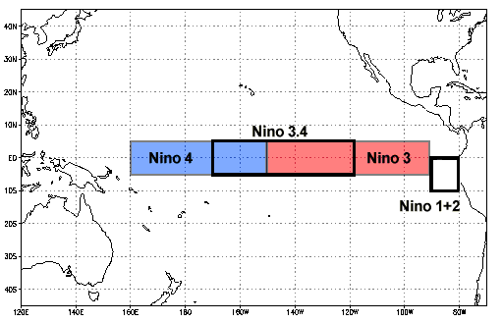](https://www.ncdc.noaa.gov/monitoring-content/teleconnections/nino-regions.gif)](https://www.ncdc.noaa.gov/monitoring-content/teleconnections/nino-regions.gif)

Historically, scientists have classified the intensity of El Niño based on SST anomalies exceeding a pre-selected threshold in a certain region of the equatorial Pacific. The most commonly used region is the Niño 3.4 region, and the most commonly used threshold is a positive SST departure from normal greater than or equal to +0.5°C. Since this region encompasses the western half of the equatorial cold tongue region, it provides a good measure of important changes in SST and SST gradients that result in changes in the pattern of deep tropical convection and atmospheric circulation. The criteria, that is often used to classify El Niño episodes, is that five consecutive 3-month running mean SST anomalies exceed the threshold.

Studies have shown that a necessary condition for the development and persistence of deep convection (enhanced cloudiness and precipitation) in the Tropics is that the local SST be 28°C or greater. Once the pattern of deep convection has been altered due to anomalous SSTs, the tropical and subtropical atmospheric circulation adjusts to the new pattern of tropical heating, resulting in anomalous patterns of precipitation and temperature that extend well beyond the region of the equatorial Pacific. An SST anomaly of +0.5°C in the Niño 3.4 region is sufficient to reach this threshold from late March to mid-June. During the remainder of the year a larger SST anomaly, up to +1.5°C in November-December-January, is required in order to reach the threshold to support persistent deep convection in that region.

## Oceanic Niño Index (ONI)

Warm and cold phases are defined as a minimum of five consecutive 3-month running mean of SST anomalies ([ERSST.v4](http://www.cpc.ncep.noaa.gov/products/analysis_monitoring/ensostuff/ensoyears.shtml), 1971-2000 base period) in the Niño 3.4 region surpassing a threshold of +/- 0.5°C.

|  |  |  |  |  |  |  |  |  |  |  |  |
| --- | --- | --- | --- | --- | --- | --- | --- | --- | --- | --- | --- |
| JFM | FMA | MAM | AMJ | MJJ | JJA | JAS | ASO | SON | OND | NDJ | DJF |
| 0.4°C 0.7°F | **0.5°C 0.9°F** | **0.7°C 1.3°F** | **0.9°C 1.6°F** | **1.0°C 1.8°F** | **1.2°C 2.2°F** | **1.5°C 2.7°F** | **1.8°C 3.2°F** | **2.1°C 3.8°F** | **2.2°C 4.0°F** | **2.3°C 4.1°F** | **2.2°C 4.0°F** |
| Last 12 3-Month Running Means in Niño 3.4 Region |

*Source:*[*http://www.cpc.ncep.noaa.gov/products/analysis_monitoring/ensostuff/ensoyears.shtml*](http://www.cpc.ncep.noaa.gov/products/analysis_monitoring/ensostuff/ensoyears.shtml)

## Niño Regions Sea Surface Temperatures

|  |  |  |  |  |  |  |  |  |
| --- | --- | --- | --- | --- | --- | --- | --- | --- |
| MONTH | NIÑO 1+2 | | NIÑO 3 | | NIÑO 4 | | NIÑO 3.4 | |
| TEMP | ANOM | TEMP | ANOM | TEMP | ANOM | TEMP | ANOM | |
| March 2015 | 26.69°C (80.04°F) | 0.06°C (0.11°F) | 27.29°C (81.12°F) | 0.15°C (0.27°F) | 29.32°C (84.78°F) | 1.13°C (2.03°F) | 27.79°C (82.02°F) | 0.58°C (1.04°F) | |
| April 2015 | 26.95°C (80.51°F) | 1.35°C (2.43°F) | 28.17°C (82.71°F) | 0.67°C (1.21°F) | 29.73°C (85.51°F) | 1.23°C (2.21°F) | 28.56°C (83.41°F) | 0.78°C (1.40°F) | |
| May 2015 | 26.71°C (80.08°F) | 2.43°C (4.37°F) | 28.28°C (82.90°F) | 1.19°C (2.14°F) | 29.88°C (85.78°F) | 1.09°C (1.96°F) | 28.88°C (83.98°F) | 1.03°C (1.85°F) | |
| June 2015 | 25.42°C (77.76°F) | 2.54°C (4.57°F) | 28.10°C (82.58°F) | 1.66°C (2.99°F) | 29.93°C (85.87°F) | 1.09°C (1.96°F) | 28.96°C (84.13°F) | 1.32°C (2.38°F) | |
| July 2015 | 24.48°C (76.06°F) | 2.87°C (5.17°F) | 27.79°C (82.02°F) | 2.17°C (3.91°F) | 29.80°C (85.64°F) | 1.00°C (1.80°F) | 28.82°C (83.88°F) | 1.60°C (2.88°F) | |
| August 2015 | 22.88°C (73.18°F) | 2.24°C (4.03°F) | 27.33°C (81.19°F) | 2.34°C (4.21°F) | 29.66°C (85.39°F) | 0.98°C (1.76°F) | 28.89°C (84.00°F) | 2.07°C (3.73°F) | |
| September 2015 | 22.91°C (73.24°F) | 2.57°C (4.63°F) | 27.48°C (81.46°F) | 2.63°C (4.73°F) | 29.73°C (85.51°F) | 1.04°C (1.87°F) | 29.00°C (84.20°F) | 2.28°C (4.10°F) | |
| October 2015 | 23.31°C (73.96°F) | 2.52°C (4.54°F) | 27.58°C (81.64°F) | 2.66°C (4.79°F) | 29.79°C (85.62°F) | 1.12°C (2.02°F) | 29.15°C (84.47°F) | 2.46°C (4.43°F) | |
| November 2015 | 23.83°C (74.89°F) | 2.24°C (4.03°F) | 27.91°C (82.24°F) | 2.93°C (5.27°F) | 30.30°C (86.54°F) | 1.67°C (3.01°F) | 29.60°C (85.28°F) | 2.95°C (5.31°F) | |
| December 2015 | 25.01°C (77.02°F) | 2.19°C (3.94°F) | 27.99°C (82.38°F) | 2.85°C (5.13°F) | 30.11°C (86.20°F) | 1.63°C (2.93°F) | 29.39°C (84.90°F) | 2.82°C (5.08°F) | |
| January 2016 | 25.93°C (78.67°F) | 1.41°C (2.54°F) | 28.21°C (82.78°F) | 2.58°C (4.64°F) | 29.65°C (85.37°F) | 1.35°C (2.43°F) | 29.17°C (84.51°F) | 2.60°C (4.68°F) | |
| February 2016 | 26.81°C (80.26°F) | 0.67°C (1.21°F) | 28.36°C (83.05°F) | 1.99°C (3.58°F) | 29.55°C (85.19°F) | 1.45°C (2.61°F) | 29.12°C (84.42°F) | 2.40°C (4.32°F) | |
| Feb - Jan Difference | 0.88°C | -0.74°C | 0.15°C | -0.59°C | -0.10°C | 0.10°C | -0.05°C | -0.20°C | |
| 1.58°F | -1.33°F | 0.27°F | -1.06°F | -0.18°F | 0.18°F | -0.09°F | -0.36°F | |
| Last 12 Months |

*Source:*[*http://www.cpc.ncep.noaa.gov/data/indices/sstoi.indices*](http://www.cpc.ncep.noaa.gov/data/indices/sstoi.indices)

SST values in the Niño 3.4 region may not be the best choice for determining La Niña episodes but, for consistency, the index has been defined by negative anomalies in this area. A better choice might be the [Niño 4 region](https://www.ncdc.noaa.gov/monitoring-content/teleconnections/nino-regions.gif), since that region normally has SSTs at or above the threshold for deep convection throughout the year. An SST anomaly of -0.5°C in that region would be sufficient to bring water temperatures below the 28°C threshold, which would result in a significant westward shift in the pattern of deep convection in the tropical Pacific.

Sea surface temperature anomalies were calculated using the Extended Reconstructed Sea Surface Temperature version 4 ([ERSST.v4](https://www.ncdc.noaa.gov/data-access/marineocean-data/extended-reconstructed-sea-surface-temperature-ersst-v4)).

For more information on El Niño and La Niña, please visit [NOAA's El Niño information website](http://www.elnino.noaa.gov/).

**NORTH AMERICAN COUNTRIES REACH CONSENSUS ON EL NIÑO DEFINITION**

[NOAA](http://www.noaa.gov/) announced that the [NOAA National Weather Service](http://www.nws.noaa.gov/), the[Meteorological Service of Canada](http://www.msc-smc.ec.gc.ca/contents_e.html) and the [National Meteorological Service of Mexico](http://smn.cna.gob.mx/) have reached a consensus on an index and definitions for [El Niño and La Niña](http://www.cpc.ncep.noaa.gov/products/analysis_monitoring/lanina/) events.

The index is defined as a three-month average of sea surface temperature departures from normal for a critical region of the equatorial Pacific (Niño 3.4 region; 120W-170W, 5N-5S). This region of the tropical Pacific contains what scientists call the "equatorial cold tongue," a band of cool water that extends along the equator from the coast of South America to the central Pacific Ocean. Departures from average sea surface temperatures in this region are critically important in determining major shifts in the pattern of tropical rainfall, which influence the jet streams and patterns of temperature and precipitation around the world.

North America's operational definitions for El Niño and La Niña, based on the index, are:  
El Niño: A phenomenon in the equatorial Pacific Ocean characterized by a positive sea surface temperature departure from normal (for the 1971-2000 base period) in the Niño 3.4 region greater than or equal in magnitude to 0.5 degrees C (0.9 degrees Fahrenheit), averaged over three consecutive months.

La Niña: A phenomenon in the equatorial Pacific Ocean characterized by a negative sea surface temperature departure from normal (for the 1971-2000 base period) in the Niño 3.4 region greater than or equal in magnitude to 0.5 degrees C (0.9 degrees Fahrenheit), averaged over three consecutive months.

(NOAA News Online, Feb. 23, 2005)

Southern Oscillation Index

The **Southern Oscillation Index**, or SOI, gives an indication of the development and intensity of El Niño or La Niña events in the Pacific Ocean. The SOI is calculated using the pressure differences between Tahiti and Darwin.

Sustained negative values of the SOI below −7 often indicate [El Niño](http://www.bom.gov.au/climate/glossary/elnino.shtml) episodes. These negative values are usually accompanied by sustained warming of the central and eastern tropical Pacific Ocean, a decrease in the strength of the Pacific Trade Winds, and a reduction in winter and spring rainfall over much of eastern Australia and the Top End. You can read more about historical El Niño events and their effect on Australia in the [Detailed analysis of past El Niño events](http://www.bom.gov.au/climate/enso/enlist/).

Sustainted positive values of the SOI above +7 are typical of a [La Niña](http://www.bom.gov.au/climate/glossary/lanina.shtml) episode. They are associated with stronger Pacific [trade winds](http://www.bom.gov.au/climate/glossary/trade_winds.shtml) and warmer sea temperatures to the north of Australia. Waters in the central and eastern tropical Pacific Ocean become cooler during this time. Together these give an increased probability that eastern and northern Australia will be wetter than normal. You can read more about historical La Niña events and their effect on Australia in the [Detailed analysis of past La Niña events](http://www.bom.gov.au/climate/enso/lnlist/).

The [ENSO Wrap-Up](http://www.bom.gov.au/climate/enso) includes the latest 30-day SOI value, as well as other information on indicators of El Niño and La Niña events.

The graph below shows monthly values of the SOI in recent years.

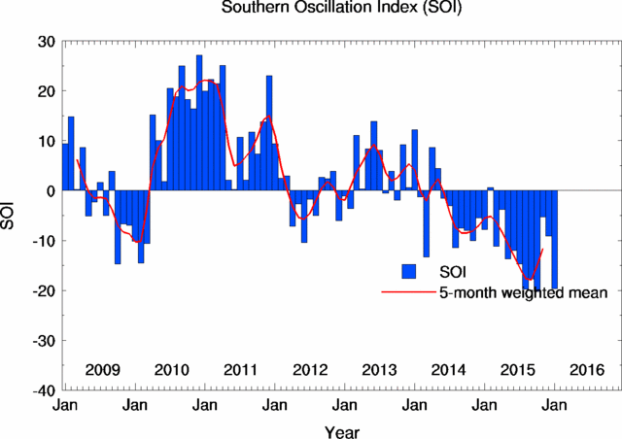

**For the mathematically minded:**  
There are a few different methods of how to calculate the SOI. The method used by the Australian Bureau of Meteorology is the Troup SOI which is the standardised anomaly of the Mean Sea Level Pressure difference between Tahiti and Darwin. It is calculated as follows:

[ Pdiff - Pdiffav ]

SOI = 10 -------------------

SD(Pdiff)

where   
Pdiff   =   (average Tahiti MSLP for the month) - (average Darwin MSLP for the month),  
Pdiffav   =   long term average of Pdiff for the month in question, and  
SD(Pdiff)   =   long term standard deviation of Pdiff for the month in question.

The multiplication by 10 is a convention. Using this convention, the SOI ranges from about –35 to about +35, and the value of the SOI can be quoted as a whole number. The dataset the Bureau uses has 1933 to 1992 as the climatology period. The SOI is usually computed on a monthly basis, with values over longer periods such a year being sometimes used. Daily or weekly values of the SOI do not convey much in the way of useful information about the current state of the climate, and accordingly the Bureau of Meteorology does not issue them. Daily values in particular can fluctuate markedly because of daily weather patterns, and should not be used for climate purposes.

## Tree Data Structure

There are many basic data structures that can be used to solve application problems. Array is a good static data structure that can be accessed randomly and is fairly easy to implement. Linked Lists on the other hand is dynamic and is ideal for application that requires frequent operations such as add, delete, and update. One drawback of linked list is that data access is sequential. Then there are other specialized data structures like, stacks and queues that allows us to solve complicated problems (eg: Maze traversal) using these restricted data structures. One other data structure is the hash table that allows users to program applications that require frequent search and updates. They can be done in O(1) in a hash table.

One of the disadvantages of using an array or linked list to store data is the time necessary to search for an item. Since both the arrays and Linked Lists are **linear structures**the time required to search a “linear” list is proportional to the size of the data set. For example, if the size of the data set is n, then the number of comparisons needed to find (or not find) an item may be as bad as some multiple of n. So imagine doing the search on a linked list (or array) with n = 106 nodes. Even on a machine that can do million comparisons per second, searching for m items will take roughly m seconds. This not acceptable in today’s world where speed at which we complete operations is extremely important. Time is money. Therefore it seems that better (more efficient) data structures are needed to store and search data.

In this chapter, we can extend the concept of linked data structure (linked list, stack, queue) to a structure that may have multiple relations among its nodes. Such a structure is called a **tree**. A tree is a collection of nodes connected by directed (or undirected) edges. A tree is a *nonlinear* data structure, compared to arrays, linked lists, stacks and queues which are linear data structures. A tree can be empty with no nodes or a tree is a structure consisting of one node called the **root** and zero or one or more subtrees. A tree has following general properties:

* One node is distinguished as a **root**;
* Every node (exclude a root) is connected by a directed edge *from* exactly one other node; A direction is: *parent -> children*  
  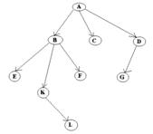

A is a parent of B, C, D,   
B is called a child of A.   
on the other hand, B is a parent of E, F, K

In the above picture, the root has 3 subtrees.

Each node can have *arbitrary* number of children. Nodes with no children are called **leaves**, or **external** nodes. In the above picture, C, E, F, L, G are leaves. Nodes, which are not leaves, are called **internal** nodes. Internal nodes have at least one child.

Nodes with the same parent are called **siblings**. In the picture, B, C, D are called siblings.  The **depth of a node** is the number of edges from the root to the node. The depth of K is 2.  The **height of a node** is the number of edges from the node to the deepest leaf. The height of B is 2. The **height of a tree** is a height of a root.

**A General Tree**

A general tree is a tree where each node may have zero or more children (a binary tree is a specialized case of a general tree). General trees are used to model applications such as file systems.

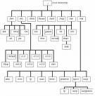

**Figure courtesy of www.washington.edu**

**Implementation**

Since each node in a tree can have an arbitrary number of children, and that number is not known in advance, the *general* tree can be implemented using a **first child/next sibling** method. Each node will have **TWO** pointers: one to the leftmost child, and one to the rightmost sibling. The following picture illustrates this

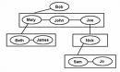

**Figure courtesy of**[www.gamedev.net](http://www.gamedev.net/)

The following Java code may be used to define a general tree node.

**public class TNode {**

**private Object  data;**

**private MyLinkedList siblings;**

**private TNode myLeftChild;**

**public TNode(Object n){data=n; siblings=NULL;myLeftChild=NULL;}**

**}**

**Binary Trees**

*We will see* that dealing with **binary** trees, a tree where each node can have no more than two children is a good way to understand trees.

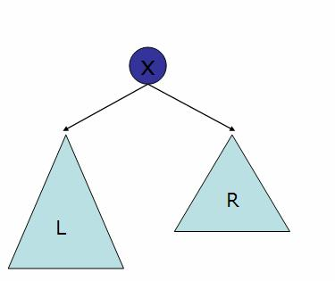

Here is a Java prototype for a tree node:

public class BNode

{

   private Object data;

   private BNode left, right;

   public BNode()

   {

      data=left=right=null;

   }

   public BNode(Object data)

   {

      this.data=data;

      left=right=null;

   }

}

A binary tree in which each node has exactly zero or two children is called **a full binary tree**. In a full tree, there are no nodes with exactly one child.

**A complete binary tree** is a tree, which is completely filled, with the possible exception of the bottom level, which is filled from left to right. A complete binary tree of the height h has between 2hand 2(h+1)-1 nodes. Here are some examples:

**full tree                                                   complete tree**

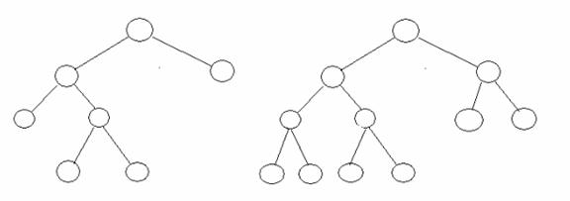

**Binary Search Trees**

Given a binary tree, suppose we visit each node (recursively) as follows. We visit left child, then root and then the right child. For example, visiting the following tree

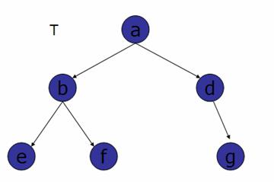

In the order defined above will produce the sequence {e, b,f,a,d,g} which we call flat(T). A binary search tree (BST) is a tree, where flat(T) is an ordered sequence. In other words, a binary search tree can be “searched” efficiently using this ordering property. A “balanced” binary search tree can be searched in O(log n) time, where n is the number of nodes in the tree.

In the next lesson we will learn some of the operations on BST’s.